Objectives

- Explain branching and merging
- Explain about creating a branch request in GitLab
- Explain about creating a merge request in GitLab

In this hands-on lab, you will learn how to:
- Construct a branch, do some changes in the branch, and merge it with master (or trunk)

Prerequisites

The following are the pre-requisites to complete this hands-on lab:
- Setting up Git environment with P4Merge tool for Windows

Notes*:
Please follow the below steps for creating a free account in GitHub.
Do not use cognizant credentials to login to GitHub.

Estimated time to complete this lab: 30 minutes.
Please follow the instruction to complete the hands-on. Each instruction expects a command for the Git Bash.

Branching:
- Create a new branch “GitNewBranch”.
- List all the local and remote branches available in the current trunk. Observe the “*” mark which denote the current pointing branch.
- Switch to the newly created branch. Add some files to it with some contents.
- Commit the changes to the branch.
- Check the status with “git status” command.
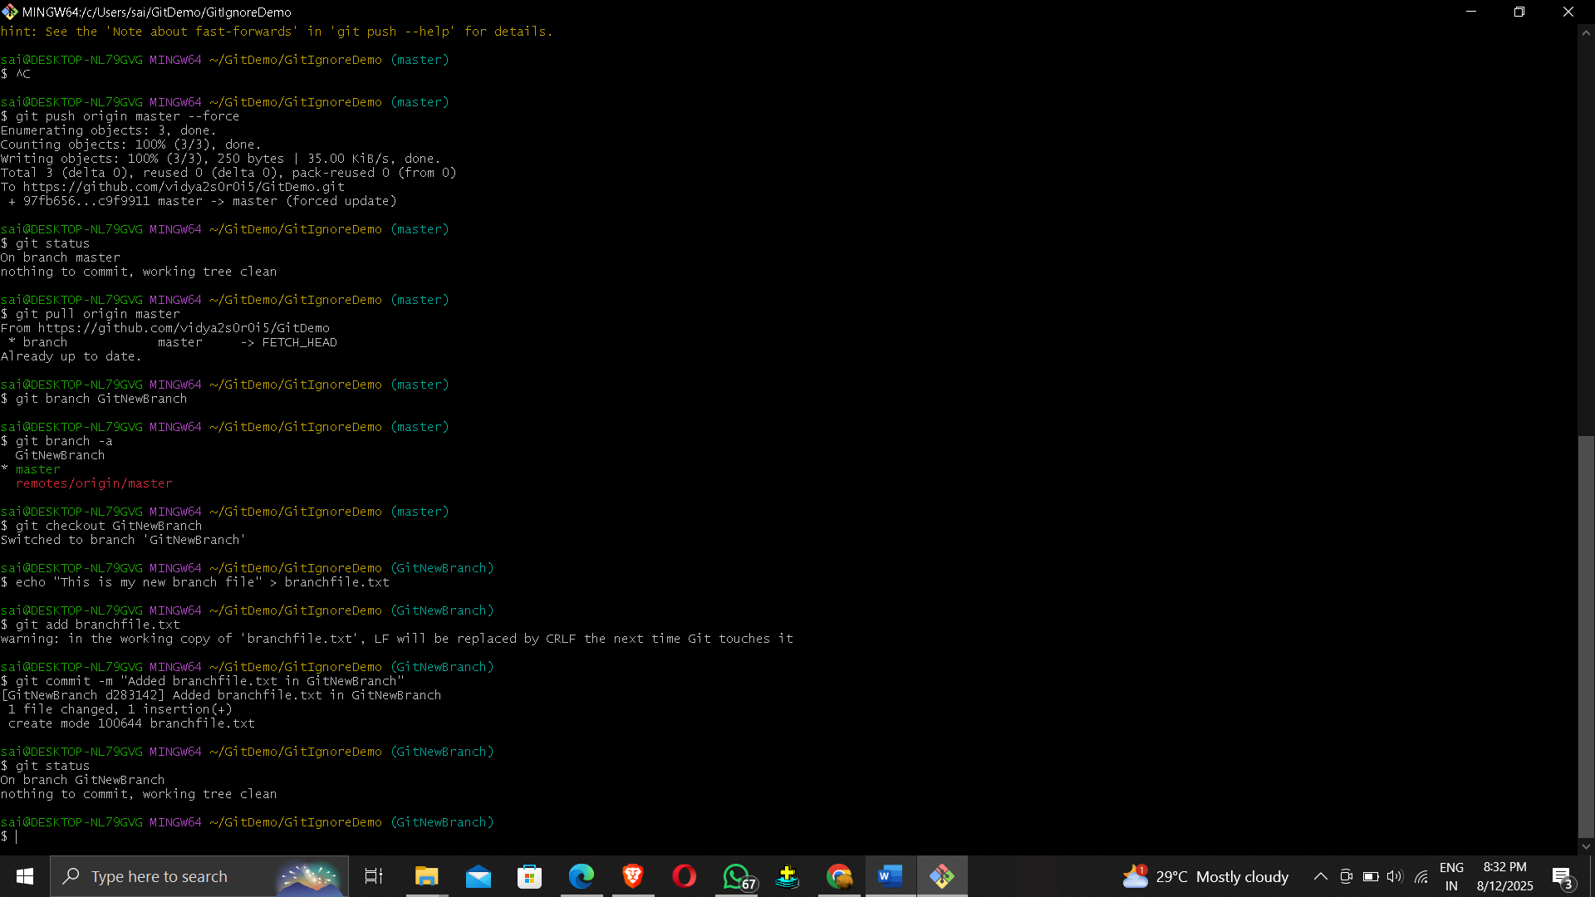

Merging:
- Switch to the master
- List out all the differences between trunk and branch. These provide the differences in command line interface.
- List out all the visual differences between master and branch using P4Merge tool.
- Merge the source branch to the trunk.
- Observe the logging after merging using “git log –oneline –graph –decorate”
- Delete the branch after merging with the trunk and observe the git status.

